APPENDIX F: Health, Safety &
Environment Policy 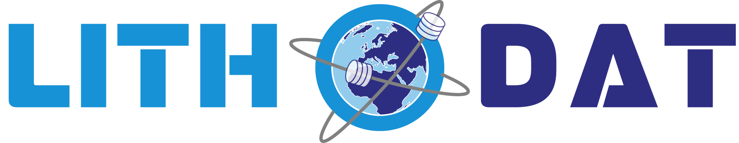
Digital Workplace Safety & Environmental Sustainability Framework GDAC-SA Advanced Analytics Platform RFQ | Lithodat Pty Ltd
Policy Overview: Lithodat is committed to maintaining a safe, healthy and environmentally responsible workplace across all operations. As a software, cloud and scientific data company working with global government and research organisations, Lithodat follows industry best practices for digital safety, environmental sustainability, and responsible workplace management. This HSE framework applies to all staff, contractors, partners and collaborators.
1. Environmental Management Approach
Although Lithodat is not an industrial or field-operations organisation, it actively incorporates environmental stewardship into its digital operations and cloud infrastructure:
Sustainable Cloud Hosting
Lithodat operates entirely on Amazon Web Services (AWS), which maintains:
100% renewable energy commitment by 2025
ISO 14001–aligned environmental management programs
Highly energy-efficient data centers
Paperless Operations
Lithodat maintains near-zero paper usage in daily operations through:
Digital invoicing, documentation and approvals
Cloud-based project management
Online collaboration with government and academic partners
Remote Work to Reduce Environmental Footprint
Most staff work remotely or hybrid, significantly reducing:
Commuting emissions
Office energy consumption
Physical infrastructure requirements
Responsible Equipment Lifecycle
Recycling and proper disposal of electronics
Sustainable procurement of IT hardware
Cloud-based processing to minimise local compute waste
2. Health and Safety Standards Followed
Lithodat's workplace health and safety framework aligns with:
ISO 45001 — Occupational Health and Safety


While not formally certified, Lithodat adheres to ISO 45001 principles, including:
Hazard identification
Risk mitigation procedures
Preventive and corrective actions
Health and safety documentation
Status: Alignment (not formally certified)
Remote & Digital Workplace Safety
Lithodat has dedicated safety measures for remote staff, including:
Ergonomic workstation guidelines
Safe home-office setup recommendations
Break and screen-time management policies
Guidelines for stress management and mental wellbeing
Inclusive and Safe Work Environment
Zero-tolerance policies for harassment or discrimination
Equal opportunity employment
Confidential mechanisms to raise concerns
3. HSE Certifications
ISO 14001 | ISO 45001 | AWS HSE Certification
⊙ Alignment Only | ⊙ Alignment Only | SOC 1/2/3 Compliance
Environmental Management | Occupational Health & Safety
Not Certified | Not Certified
Cloud Infrastructure Certification (AWS)
AWS — Lithodat's exclusive hosting environment — holds:
ISO 14001 (environmental management)
ISO 45001 (occupational safety – data center staff)
ISO 27001 / ISO 27017 / ISO 27018 (security, privacy)
SOC 1 / SOC 2 / SOC 3 compliance
Lithodat inherits these environmental and safety assurances for all hosted services.
4. Workplace Safety Policies
Lithodat maintains strong internal digital safety practices:
Ergonomics & Workspace Setup
Recommendations for adjustable desks, safe monitor height, proper lighting
Health-conscious work scheduling
Safe Work Hours & Fatigue Management
Encouragement of breaks during long coding or analysis sessions
Flexible hours to avoid overwork and stress

Mental Health & Wellbeing
Supportive culture promoting work–life balance
Manager check-ins and open communication channels
Secure Working Environments
Mandatory encrypted devices
Up-to-date antivirus and security patches
VPN and two-factor authentication for sensitive systems
5. Environmental Sustainability Initiatives
Cloud-based Workflows Reduce:
Hardware waste
Local energy consumption
On-premises server requirements
Teleconferencing-First Approach
Lithodat prioritises virtual meetings, reducing:
Domestic and international travel
Carbon footprint
Physical office footprint
Minimised Resource Consumption
Digital signatures
Cloud document storage
Minimised printing and physical documentation
6. HSE Training Programs
Lithodat provides regular internal training, including:
Training Type | Focus Areas | Frequency
Cybersecurity Awareness | Phishing prevention, password management, safe data handling | Quarterly
Remote Work Health & Safety | Ergonomic setup, healthy work practices, burnout prevention | Annual
Data Security & Privacy | Compliance training, role-based permissions, access protocols | Mandatory  (annual)
Incident Response | Reporting issues, escalation pathways, emergency communication | As needed
7. Incident Reporting Procedures
Lithodat maintains a formal incident reporting workflow for health, safety and environmental issues.
Reporting Process

1. Immediate reporting to the Managing Director or designated HSE contact
2. Incident documentation using internal digital forms
3. Root cause analysis
4. Corrective and preventive action plan
5. Follow-up assessment to ensure resolution
Types of Incidents Covered
Digital safety issues (e.g., security breaches, hardware failures)
Health issues related to remote or in-office work
Environmental concerns (e.g., equipment disposal, energy use)
Confidentiality
All reports are handled confidentially without prejudice or retaliation.
HSE Policy Summary: Lithodat maintains a robust and modern HSE framework suitable for a software, AI and scientific data company. Through ISO-aligned practices, AWS environmental and safety certifications, digital-first workplace policies, and strong incident management procedures, Lithodat ensures a safe, healthy and environmentally responsible operating environment aligned with GDAC-SA expectations.
Dr. Fabian Kohlmann
Chief Executive Officer
December 2024
Lithodat Pty Ltd | ABN: 48 647 191 452
Website:
Support: support@lithodat.com

